The Fencing Center

Our facility has features specifically designed for educating students in the sport of fencing.

- Two very large practice rooms for classes and open fencing.

- An observation area where parents can sit and watch their children during class times or open fencing.

- Armory where we teach students how to repair and maintain their fencing equipment.

- ADA compliant changing rooms where personal items can be stored during class or practice times.

- Foil, epee, and saber dummies for students to practice their technique.

- Rubberized floors that are comfortable to practice on.

- Grounded metal strips for competitive practice.

- A state-of-the-art electronic target that challenges students to improve speed and point control

Instructors

Judy O’Donnell – Head Coach
Judy has a Masters of Education from Harvard University and has been coaching fencing for 25+ years. She previously taught at the Boston Fencing Club before moving to Iowa. Judy competed internationally and has sent students to some of the highest levels of competition. She is occasionally assisted by some of her most advanced students.

Special Events

The ICFC hosts monthly 2-hour “Intro to Fencing” programs where you can give fencing a try before signing up for classes. We also have special programs for scouts, corporate team building, and other private groups.

Birthday Parties

If you want a fun and active birthday party they’ll be talking about for weeks, come to the Iowa City Fencing Center!

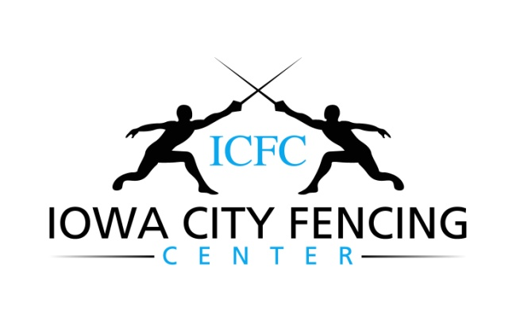

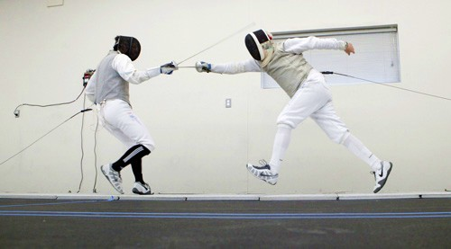

www.iowacityfencingcenter.com
icfencingcenter@gmail.com

415 Highland Ave, Suite 200
Iowa City, IA 52240

(319)-338-7171

Info

The Iowa City Fencing Center offers group classes for children ages 5 and up, teens, adults, and seniors. No experience is necessary. We have classes in all three fencing weapons: Foil, Epee, and Saber.

Half-hour and hour private lessons are available in all three weapons. Another option is semiprivate lessons for siblings, friends, or parent/child combinations.

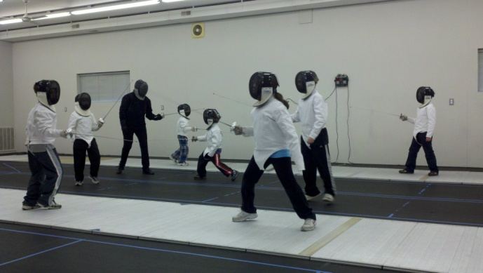

Visitors are always welcome at the ICFC! You can watch classes, open fencing, or spectate at one of the many USA Fencing tournaments we host.

Benefits of Fencing

Fencing is a fun form of exercise that improves balance, speeds up reaction times, develops mental focus, increases hand/eye coordination, and practices fast-paced problem-solving skills. It is also a great stress reliever!

Programs

Classes
Our classes start with basic footwork and blade-work while teaching students the rules of competitive fencing.

Programs progress from beginner to continuing, and advanced levels. We have an extensive class schedule from which to choose.

Footwork Sessions
Twice a week before open practice we offer a half-hour footwork session where members receive individual attention.

Open Practice
During these times members get to fence against each other and practice what they learned in class.

Home School Classes
The fencing center offers daytime classes for home school students.

Senior Citizens
While seniors may take any adult class, we also have classes designed specifically to meet the needs of senior citizens.

Summer Camps
We offer several options for all day or half day summer camp sessions.

Junior Team
Our Junior Team program is designed for youth fencers who are excited about competing at local, regional, and national tournaments.

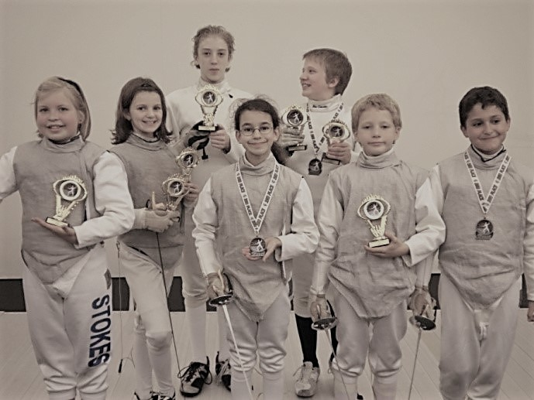

Some FAQs
Q: Is it safe?
A: Fencing is one of the ten safest Olympic sports. Our equipment meets all US Fencing Association safety standards and is meticulously inspected for safety by our staff. ICFC instructors are CPR and First Aid certified. Contrary to popular belief, we do NOT fence with sharp weapons!

Q: Do I have to buy everything at once?
A: Not at all. The ICFC provides students with everything needed to learn how to fence. We do sell equipment if you prefer to have your own. Just be sure to wear sneakers and long, comfortable pants.

Q: Can anyone do this?
A: Absolutely. Fencing is a lifetime sport where you can create a style to fit your personal strengths.

We are dedicated to creating a fun and exciting atmosphere for competitive and recreational fencers alike!

